**A000-Asia-China-Huanghuali Wood Writing Box**

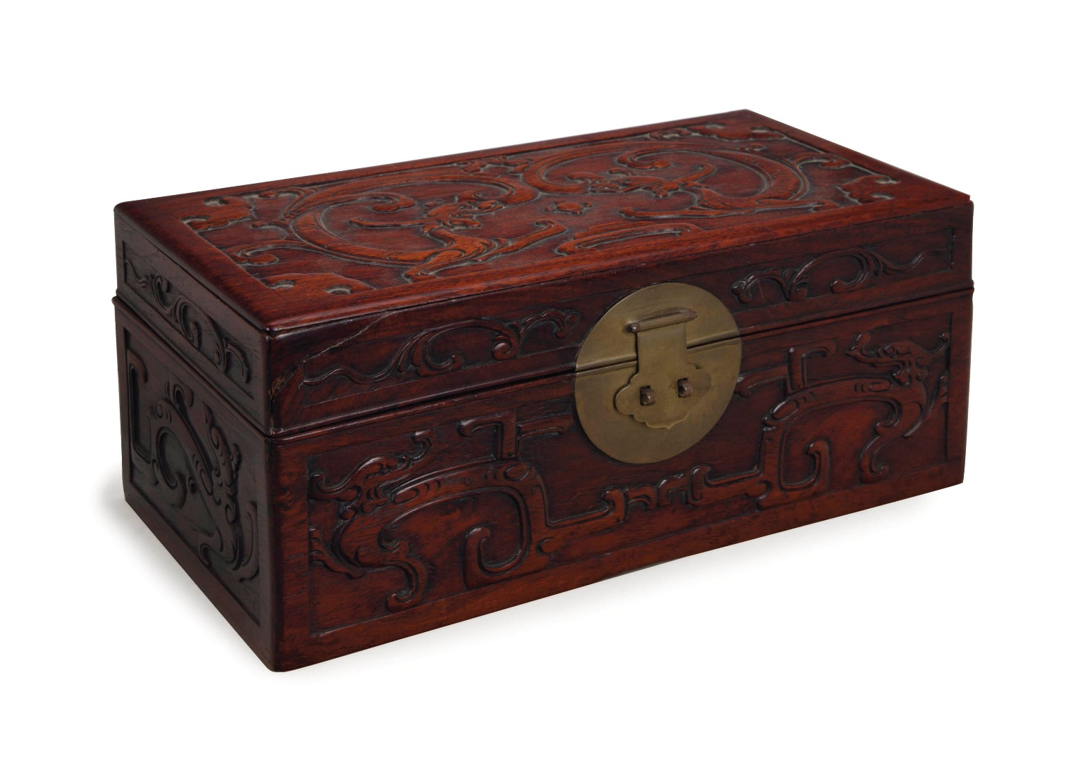

# A CHINESE CARVED HUANGHUALI BOX AND COVER,

Price realised USD 47,500

Estimate USD 2,500 - USD 3,500

A CHINESE CARVED HUANGHUALI BOX AND COVER,   
carved with confronting dragons and other stylized symbols, components possibly later assembled  
14in. (35.5cm.) long 

##### **Contact Client Service**

* [info@christies.com](mailto:info@christies.com)
* New York +1 212 636 2000